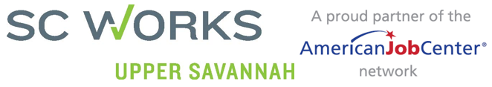
Menu of Available Business Services

- Job Postings- Online, phone call, fax, email, in-person
- Applicant screening and referral to business specifications
- Customized Recruitment
- Job Fairs and Hiring Events
- Provision of Labor Market Information
- Interviewing Space, Scheduling
- Provision of Information and referral related to:
  - Tax Credits
  - Community Resources
  - Federal Bonding
  - Americans with Disabilities Act (ADA)
  - Veterans Services
- Incumbent Worker training (as funds are available)
- On-the-job training
- Customized Training
- Information on Unemployment Insurance (UI)
- Rapid Response Services
- Trade Adjustment Assistance (TAA) information and services
- Veterans Employment Services
- Customized services for significant company or industry dislocations
- Access to WorkKeys Testing
- WorkKeys Job Profiling Services
- Database of Workkeys tested applicants
- Labor Market Information Workshops

