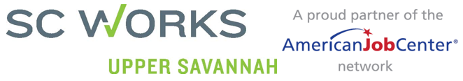
Job Search Customer Service Survey
(Circle the SC Works Center visited) Abbeville, Edgefield, Greenwood, Laurens, McCormick, Newberry, Saluda

Date: __________________________________________ | Age: __________________________________________
Thank you for telling us about your visit to the SC Works Upper Savannah Center. The following survey is voluntary and will be kept confidential. Your answers may be used to improve the services at the center.
Please answer the questions below.
- Greeting?
- Yes, I felt welcomed | - I was acknowledged
- No, but they seemed busy | - No, and they were not busy

- How useful were the computers in the resource room?
- Great | - Good, but a little slow
- Barely usable | - I did not use a computer

- The staff was knowledgeable about who was hiring and how to find those jobs.
- Yes, and they helped me navigate the listings | - Yes, but we were not able to find one for my skills
- No, they did not help

- The staff helped me create a resume.
- Yes, and I am proud of it | - Yes, but I am not satisfied
- No, but I did not want a resume | - No, I wanted help but was not assisted
5.
- Circle all of the resources that you were shown.
- SCWorks.org | - Workshop Schedule
- Hot Jobs | - Work Keys
- My Skills, My Future | - Information about community resources

- After this visit, I feel closer to finding a job.
- Yes | - No

(Optional) To be contacted about this survey or other services, please provide your contact information below.
Name:_________________________________________ | Address: _______________________________________
Phone: _________________________________________ | Email: _________________________________________

Please write any additional comments below.

