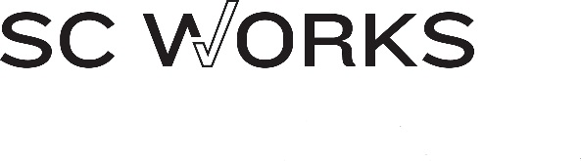
UPPER SAVANNAH WORKFORCE BOARD AGENDA

Monday, August 6, 2018
Upper Savannah Council of Governments
430 Helix Drive, Greenwood

AGENDA

Upper for Members and Invited Guests – 5:30 pm
Upper Savannah Workforce Development Board Meeting 6 p.m.
- Call to order
- Approval of Minutes
- Featured Project – Ready to Roll, Piedmont Technical College
- Regular Reports
  - Usage Reports
  - Contractor Enrollment Reports
  - Performance
- Review of 2017 Progress Towards Strategic Plan Goals
- Discussion Regarding Selecting Four Goals for Next Meeting
- Resources to Achieve Goal (Budget)
  - Request for Additional Dislocated Worker Funding
  - IT Grant
- Consideration of Youth Council Restructuring
- Regional activities to Promote Manufacturing
- Website Updates and Facebook
- Election of Chairman

Next Meeting, Monday, November 5, 2018

